Week 6
Q1. Write a C++ Program to Add Two Numbers Using a Pointer.
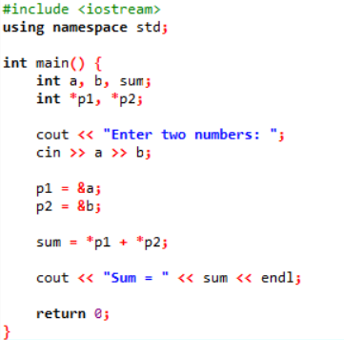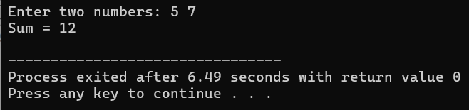
Q2. Write a C++ Example Program for swapping numbers Using Pointers.
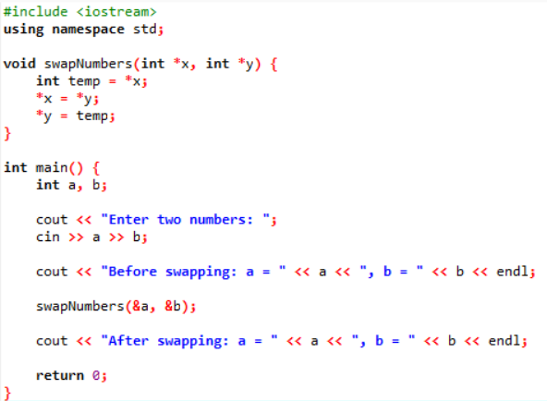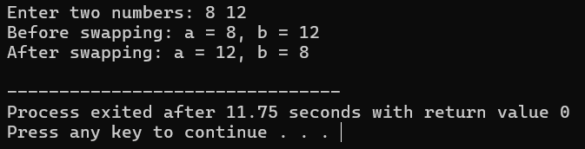
Q3. Write a C++ Program to print the address of the Variable Using a Pointer.
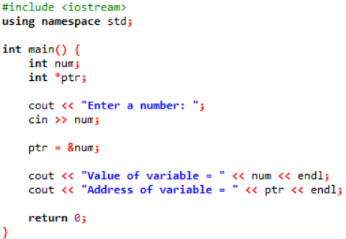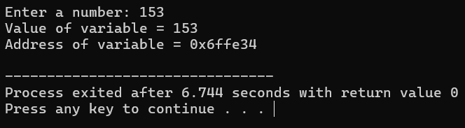
Q4. Write a C++ Program for Increment and Decrement an Integer Using a Pointer.
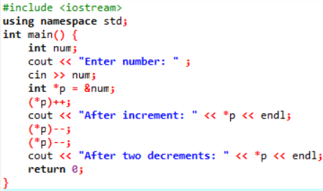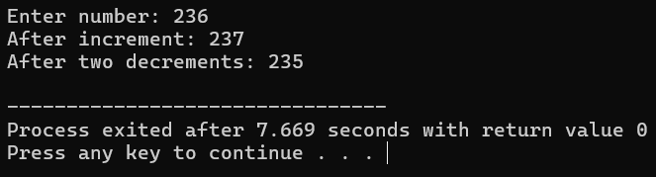

Q5. Write a C++ Program to Print a String Using a Pointer.
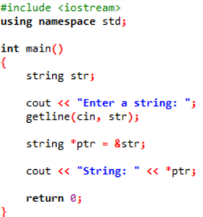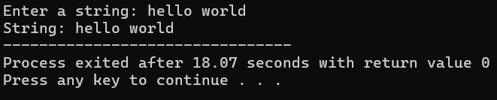
Q6. Write a C++ program to concatenate two strings using pointers.
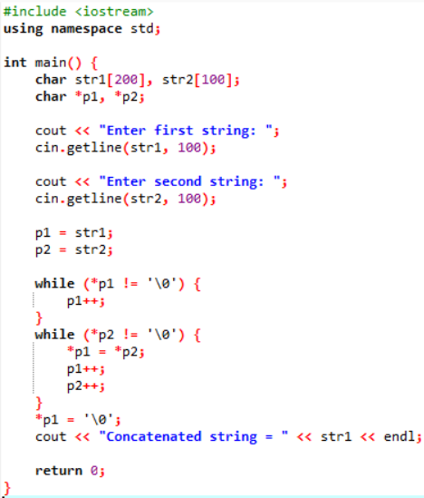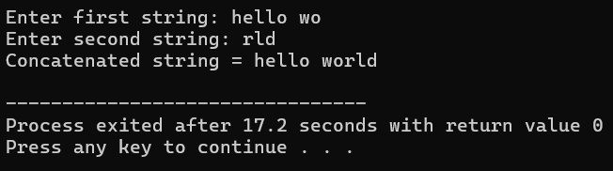
Q7. Write a program for reading elements using a pointer into an array and dis play the values using an array. i. Declare a set of elements. ii. Declare the pointer and initialize it to the first element’s address of a set of elements(array). Iii. Repeat the loop until the pointer reaches to the last element and displays each element.
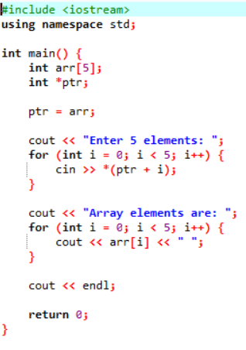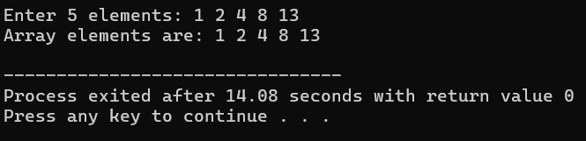
Q8. Write a program using a pointer variable to the sum of n elements from the array.
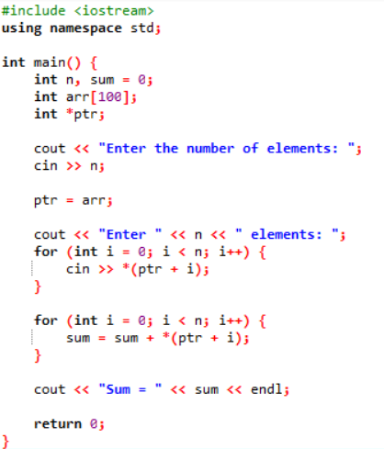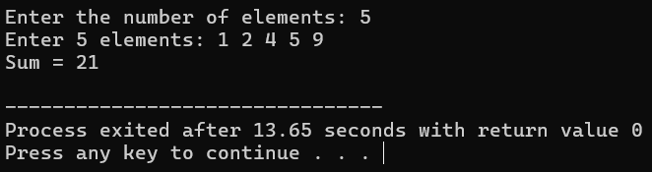
Q9. Write a program for reading elements using a pointer into the array and dis play the values using an array.
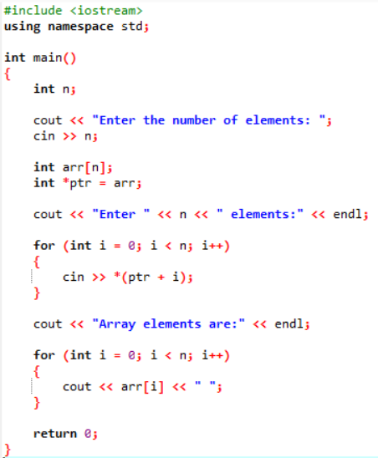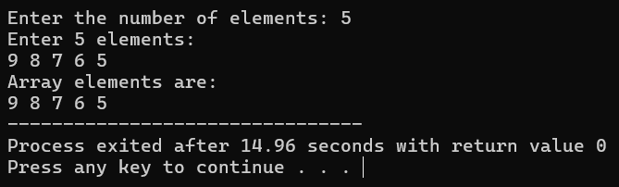

Q10. Write a C++ program to reverse a string using pointers.
